Marcos Geraldo Braga Emiliano

19.1.4012

A)

Variaveis Matriz Maquinas x Tarefas.

Dominio Para todo i,j de Matriz[i,j]{0,1}

Soma da Matriz, para maquina i e todas as tarefas de 0..tarefas = 1.

Objetivo. Minimizar Somatório de Matriz[i,j] * MatrizPesos[i,j] para todo i em maquinas e j em tarefas

B)

Min=0

Solução=( () () () () )

Início da Arvore

Raiz ( (_ _ _ _) (_ _ _ _) (_ _ _ _) (_ _ _ _) )

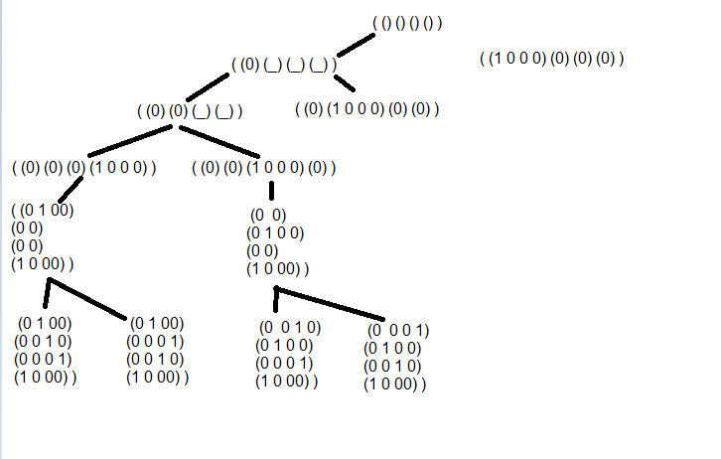

Resultados Folhas:

( (1 0 0 0) | ( (0 1 0 0) | ( (0 0 1 0) | ( (0 0 0 1) | Min = 73 Solucão = Matriz

( 0 1 0 0) | ( 0 0 1 0) | ( 0 0 0 1) | ( 1 0 0 0) | Min = 65 Solucão = Matriz

( 0 0 1 0) | ( 0 0 0 1) | ( 1 0 0 0) | ( 0 1 0 0) |

( 0 0 0 1) ) | ( 1 0 0 0) ) | ( 0 1 0 0) ) | ( 0 0 1 0) ) |

( (0 1 0 0) | ( (0 0 1 0) | ( (0 0 0 1) | ( (1 0 0 0) |

( 1 0 0 0) | ( 0 1 0 0) | ( 0 0 1 0) | ( 0 0 0 1) |

( 0 0 1 0) | ( 0 0 0 1) | ( 1 0 0 0) | ( 0 1 0 0) |

( 0 0 0 1) ) | ( 1 0 0 0) ) | ( 0 1 0 0) ) | ( 0 0 1 0) ) |

( (0 0 1 0) | ( (0 0 0 1) | ( (1 0 0 0) | ( (0 1 0 0) |

( 0 1 0 0) | ( 0 0 1 0) | ( 0 0 0 1) | ( 1 0 0 0) |

( 1 0 0 0) | ( 0 1 0 0) | ( 0 0 1 0) | ( 0 0 0 1) |

( 0 0 0 1) ) | ( 1 0 0 0) ) | ( 0 1 0 0) ) | ( 0 0 1 0) ) |

( (0 0 0 1) | ( (1 0 0 0) | ( (0 1 0 0) | ( (0 0 1 0) |

( 0 1 0 0) | ( 0 0 1 0) | ( 0 0 0 1) | ( 1 0 0 0) |

( 0 0 1 0) | ( 0 0 0 1) | ( 1 0 0 0) | ( 0 1 0 0) |

( 1 0 0 0) ) | ( 0 1 0 0) ) | ( 0 0 1 0) ) | ( 0 0 0 1) ) |

( (1 0 0 0) | ( (0 1 0 0) | ( (0 0 1 0) | ( (0 0 0 1) |

( 0 0 1 0) | ( 0 0 0 1) | ( 1 0 0 0) | ( 0 1 0 0) |

( 0 1 0 0) | ( 0 1 0 0) | ( 0 0 1 0) | ( 0 0 0 1) |

( 0 0 0 1) ) | ( 1 0 0 0) ) | ( 0 1 0 0) ) | ( 0 0 1 0) ) |

( (1 0 0 0) | ( (0 1 0 0) | ( (0 0 1 0) | ( (0 0 0 1) |

( 0 0 0 1) | ( 1 0 0 0) | ( 0 1 0 0) | ( 0 0 1 0) |

( 0 0 1 0) | ( 0 0 0 1) | ( 1 0 0 0) | ( 0 1 0 0) |

( 0 1 0 0) ) | ( 0 0 1 0) ) | ( 0 0 0 1) ) | ( 1 0 0 0) ) |

( (1 0 0 0) | ( (0 1 0 0) | ( (0 0 1 0) | ( (0 0 0 1) |

( 0 1 0 0) | ( 0 0 1 0) | ( 0 0 0 1) | ( 1 0 0 0) |

( 0 0 0 1) | ( 1 0 0 0) | ( 0 1 0 0) | ( 0 0 1 0) |

( 0 0 1 0) ) | ( 0 0 0 1) ) | ( 1 0 0 0) ) | ( 0 1 0 0) ) |